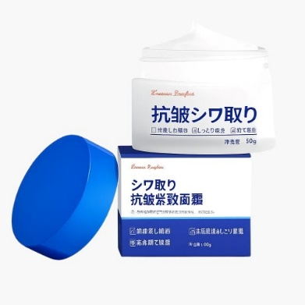
Name : wrinkle cream
Features :
1. Avocado tree butter, soft and skin-friendly, cares for the skin.
2. Carbomer, removes melanin, purifies the skin.
3. Hydrolyzed silk, regenerating vitality, helps elasticity and completeness.
4. Smoothes facial wrinkles, firming Anti-free radicals, anti-oxidation.
How to use :
Cleanse and tone your face.
Take a pea-sized amount of wrinkle cream.
Gently massage it onto your face and neck, focusing on areas with fine lines.
Use morning and night for best results.

